

Freshco Hypermarket Capstone

DHIVYALAKSHMI K B | DAP-202407-1 | 25/08/2024

|  |
| --- |
| TABLE OF CONTENTS |
| * Introduction |
| * Order level Analysis |
| * Customer Level Analysis |
| * Delivery Analysis |
| * Completion Rate Analysis. |
| * Annexure |

INTRODUCTION

Freshco Hypermarket, situated in HSR, Bangalore, has established itself as a prominent supermarket in the region, catering to a wide range of customers. In response to evolving customer needs and to enhance convenience, Freshco introduced a home delivery service in the year 2021. To ensure seamless operations and optimize customer satisfaction, the store diligently maintained a comprehensive transaction data sheet, containing detailed information at the order level.

This analysis presents valuable Insights on Freshco Hypermarket’s Sales in various levels such as

• Order Level Analysis

• Completion Rate Analysis

• Delivery Level Analysis

• Customer Level Analysis

This analysis is done as part of SKilloVilla’s Capstone Project

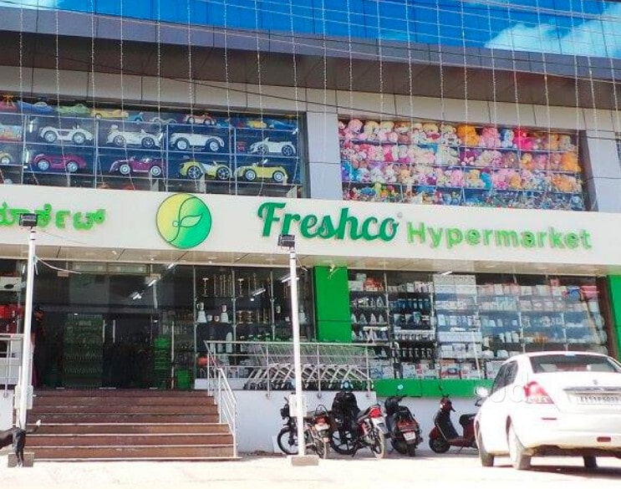

ORDER LEVEL ANALYSIS

By performing Order level analysis, we can get Insights on various Order intake patterns across various level. It also helps to analyze how different elements such as Order count, Delivery charges, Discount varies at each level of Analysis.

Also, in the Analysis given we have no. of orders spread across Slots, Months and days based on the Order intake.

VARIOUS LEVEL OF ANALYSIS DONE :

1. Identifying order distribution at slot and delivery area level.

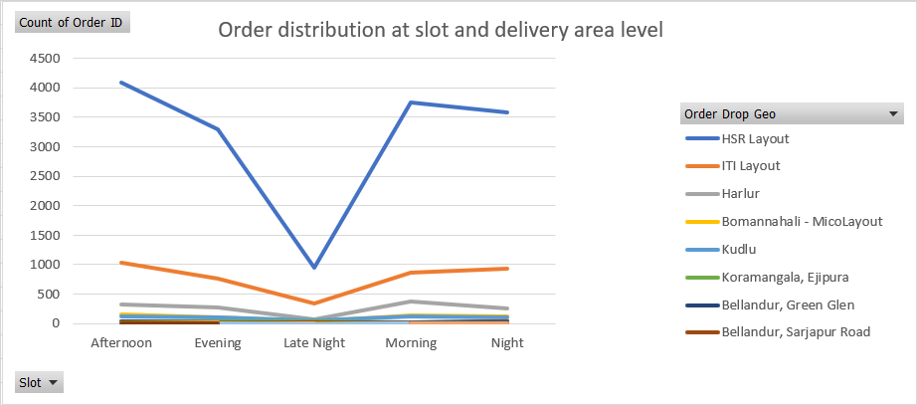

INSIGHTS

* HSR Layout, ITI Layout, Harlur, Bomannahali-Micolayout, Kudlu are the top 5 Order drop geos having high Order count.
* Similarly, Cox Town, Whitefield, Vimanapura, Challagatta, Kadubeesanhali, PTP, Mahadevapura, Victoria Layout, JP Nagar Phase 8-9, Bellandur, Ecospace, CV Raman Nagar, Binnipet, Pattandur, Brookefield, Frazer Town are having least order count with ‘1’ order each.
* Order Intake during Afternoon slot is maximum
* Similarly, Order Intake during Late Night slot is minimum

1. Identifying the areas having highest increase in monthly orders (from Jan to Sep) in absolute orders.

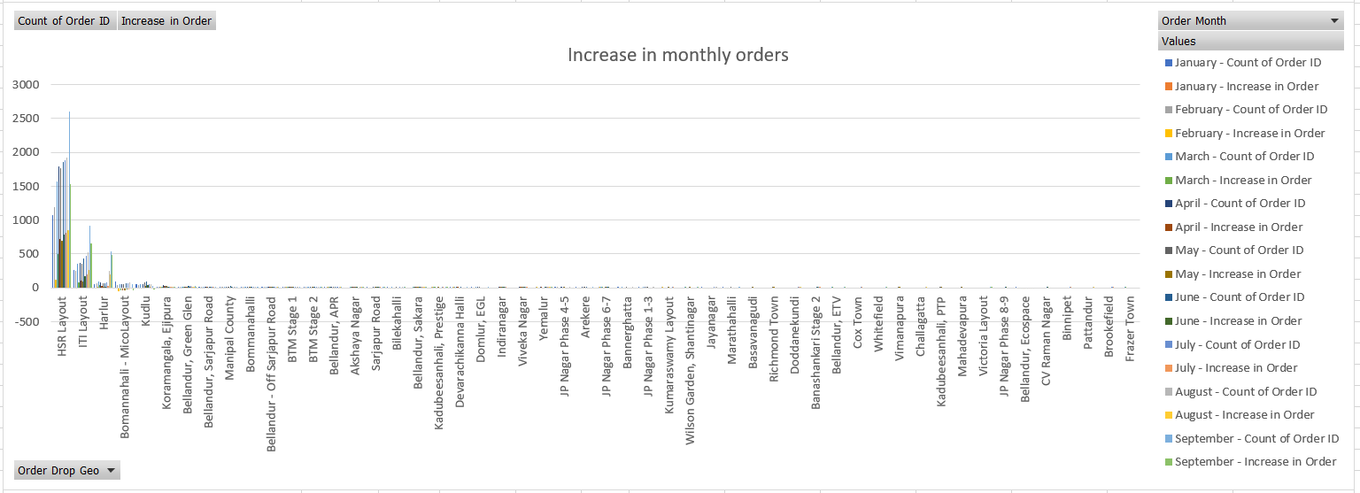

INSIGHTS

* HSR Layout, ITI Layout, Harlur, Bomannahali-Micolayout, Kudlu are the top 5 Order drop geos having highest increase in monthly orders .
* Similarly, Cox Town, Whitefield, Vimanapura, Challagatta, Kadubeesanhali, PTP, Mahadevapura, Victoria Layout, JP Nagar Phase 8-9, Bellandur, Ecospace, CV Raman Nagar, Binnipet, Pattandur, Brookefield, Frazer Town are having lowest increase in monthly orders.

1. Calculate delivery charges as a percentage of product amount at slot and month level.

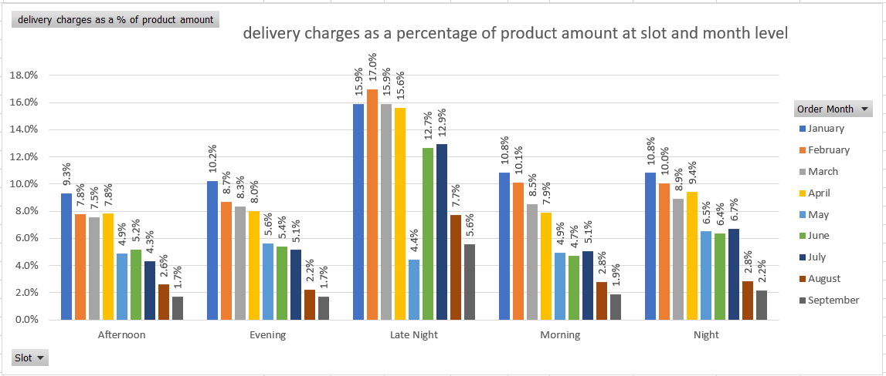

INSIGHTS

* Delivery charges are high for late Night Orders
* Similarly, Delivery charges are low for Afternoon Orders
* Delivery charges across different slots for September is Low
* Similarly, Delivery charges across different slots for January is high when compared to other months

1. Calculate discount as a percentage of product amount at slot and month level.

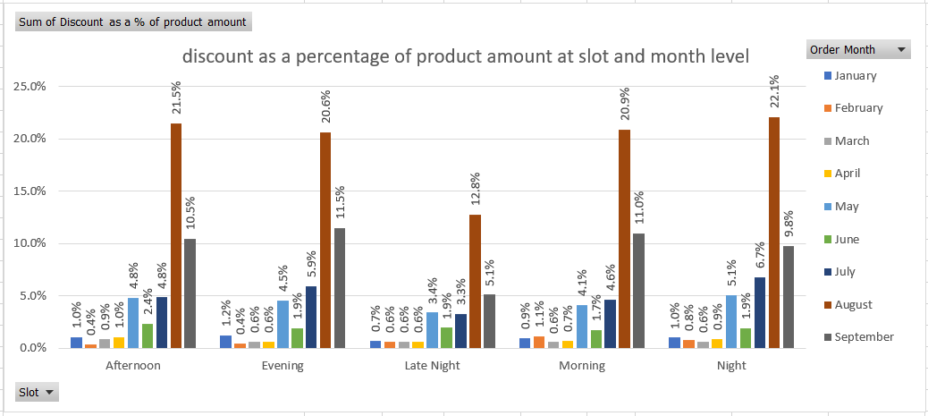

INSIGHTS

* Discounts are high for Night Orders
* Similarly, Discounts are low for Late Night Orders
* Discounts across different slots for August is High
* Similarly, Discounts across different slots for February is low when compared to other months

5. Calculate discount as a percentage of product amount at drop area and slot level.

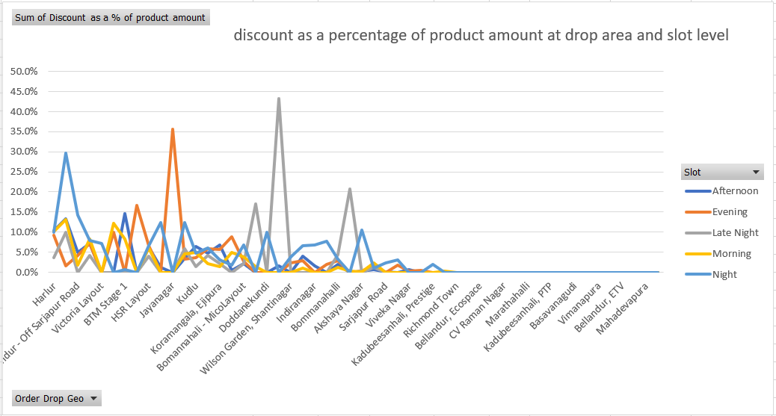

INSIGHTS

* Discounts are high for Night Orders
* Similarly, Discounts are low for Late Night Orders
* Harlur, Bilekahalli, Bellandur - Off Sarjapur Road, ITI Layout, Victoria Layout are the top 5 Order Drop Geos having high Discount%
* Richmond Town, Whitefield, Bellandur, Ecospace, Binnipet, CV Raman Nagar,Challagatta, Marathahalli, Pattandur,Kadubeesanhali, PTP, Banashankari Stage 2,Basavanagudi, Cox Town, Vimanapura,Brookefield, Bellandur, ETV, Kumaraswamy Layout, Mahadevapura, Frazer Town are having least Discount%

FACTORS AFFECTING ORDER COUNT

* CUSTOMER SERVICE
  + DISCOUNT : Low discounts can affect count of orders as it does not attract the consumers quickly.
  + PROMOTIONS / OFFERS : No or Low promotions / Offers can tend to attract very less consumers
  + PAYMENT OPTIONS : Restricting to fewer payment methods provide less options for consumers to pay
* OPERATIONAL CHARGES
  + DELIVERY CHARGES : High delivery charges leads to consumers moving out to other vendors with better operational charges
  + SURGE FEES : Inducing Surge fees for extra distance or during extreme climatic conditions fails in attracting consumers
* ECONOMIC FACTORS
  + INCREASED PRICE OF PRODUCTS : Products price can be increased due to less production of raw materials, high import/export charges etc.,
  + PRODUCT QUALITY & QUANTITY : There can be low quality goods produced due to pandemic, climatic conditions or unavailability of farm products
* COMPETITION
  + BETTER PRICE : Opposition sales platform can provide better price to attract more consumers.
  + BETTER CUSTOMER SERVICE : Opposition sales platform can provide more discounts, promotions.
* UNFORSEEN FACTORS
  + DELIVERY RESTRICTIONS : Some Geos can be zoned to restrict delivery
  + NATURAL CALAMITIES : Floods, Earthquakes and more

SOME OF THE BEST PRACTICES TO IMPROVE ORDERS

* Increasing discount% for each product without affecting overall profit of the company
* Providing special offers or User specific Promotion codes which helps in attracting more consumers
* Improving Marketing strategies via social media and other platforms
* Providing possible payment options during checkout
* Making sure to provide best consumer service and compete with the opposition parties in a healthy way
* Improving website navigations and clean UI
* Attractive hoardings and posters

COMPLETION RATE ANALYSIS

By performing Completion Rate analysis, we can get Insights on completion rate patterns differing across various level. It also helps to analyze how Completion rate differs with various elements such as slots, delivery Geos, weekdays, no.of products .

Also, in the Analysis given we have Completion rate calculated across Slots, Months and days of the week.

VARIOUS LEVEL OF ANALYSIS DONE :

Average Completion Rate : 99.55%

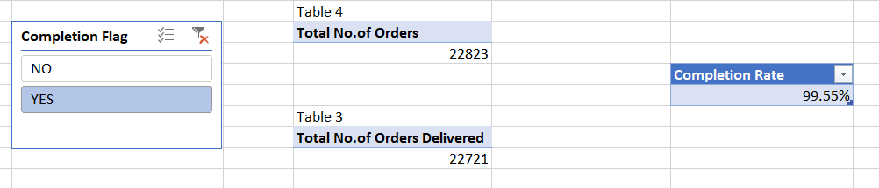

6. Identify Completion rate at slot vs day of the week (Sunday to Saturday) level. Can you spot some pattern in the data?

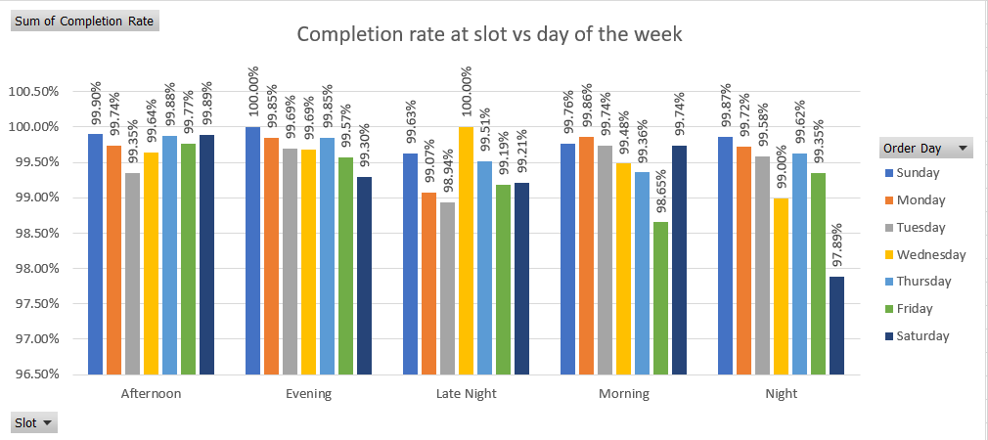

INSIGHTS

* Sunday has high Completion rate
* Similarly, Saturday has low Completion rate
* Completion rate during Afternoon slot is maximum
* Similarly, Completion rate during Night slot is minimum

7. Calculate completion rate at drop area level.

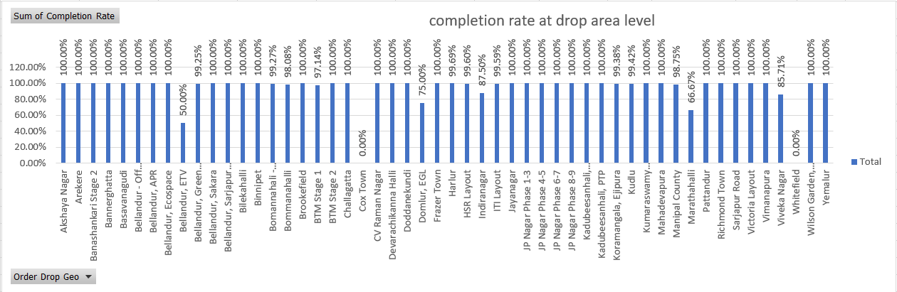

INSIGHTS

* Cox Town, Whitefield are having 0 successful orders and hence having 0% completion rate.
* Bellandur ETV has 50% completion rate

8. Completion rate at number of products ordered level. For this first you need to create a column having number of products against every order.

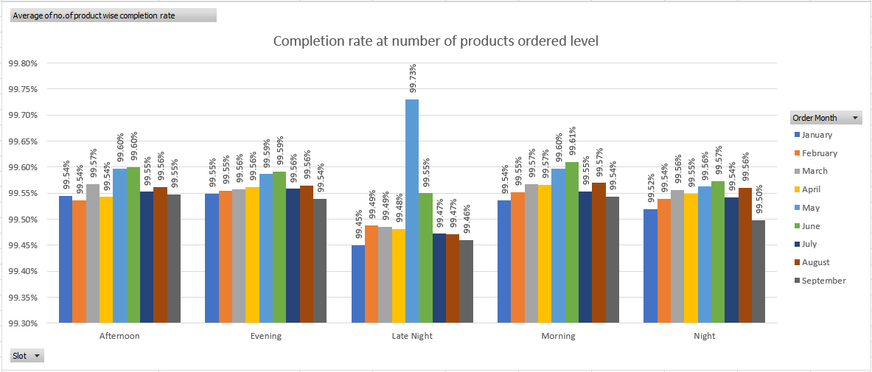

INSIGHTS

* During May month at Late night slot, completion rate is highest around 99.73%.
* Whereas, during January month at Late night slot, completion rate is lowest around 99.45%.
* May and June month has average Completion rate of 99.59% across various slots.

9. Give you analysis on the any pattern you observe in the completion rate.

* Cox Town, Whitefield are having 0 successful orders and hence having 0% completion rate.
* Bellandur ETV has 50% completion rate
* During May month at Late night slot, completion rate is highest around 99.73%.
* Whereas, during January month at Late night slot, completion rate is lowest around 99.45%.
* May and June month has average Completion rate of 99.59% across various slots.
* Sunday has high Completion rate
* Similarly, Saturday has low Completion rate
* Completion rate during Afternoon slot is maximum
* Similarly, Completion rate during Night slot is minimum

FACTORS AFFECTING COMPLETION RATE

* LABOUR AND MANPOWER
  + EMPLOYEE ABSENTEEISM : Reduced number of staffs engaged in delivery can delay in delivering the orders.
  + WORKPLACE ACCIDENTS : Accidents during work hours while delivering a product can lead to delay in delivery which may lead to consumer cancelling the order or the package getting damaged
* OPERATIONAL CHARGES
  + LABOUR CHARGES : Insufficient salary to the delivery partners can result in dissatisfaction of the staffs.
  + INCENTIVES : If there are no performance-based Incentives given to the staffs, they will lack motivation and disagree to work on late night shifts
* CONSUMER RELATED FACTORS
  + UNAVAILABILITY OF CONSUMER : If the consumer is not available during the time of delivery, it may cause cancellation
  + UNRESPONSIVE CONSUMERS : If the consumers are not responding to phone calls or messages from the delivery partners, the order cannot be completed
  + INAPPROPRIATE ADDRESS : If the consumer has provided wrong address, it may affect delivery timings and eventually leads to cancellation
* UNFORSEEN FACTORS
  + DELIVERY RESTRICTIONS : Some Geos can be zoned to restrict delivery
  + NATURAL CALAMITIES : Floods, Earthquakes and more
  + ROAD TRAFFIC & ROAD BLOCKS : Heavy traffic or road blocks can lead to extended delivery hours

SOME OF THE BEST PRACTICES TO IMPROVE COMPLETION RATE

* Making sure to follow rotational shift system to have staffs knowledgeable staffs at each shift.
* Taking spontaneous decisions to have complete all the deliveries for the day during emergency or unplanned leave of a staff member.
* Increasing salary of the deliver partners in a yearly manner based on their experience without affecting overall profit of the company
* Providing Incentives and special coupons for delivery partners based on their performance will motivate them to work more.
* Training the delivery partners to tackle situations when the consumer is unresponsive
* Educate the delivery partners about GPS and other navigation technologies to overcome unforeseen factors and attempt delivery

CUSTOMER LEVEL ANALYSIS

By performing Customer level analysis, we can get Insights on Total Revenue produced by the consumers from various acquisition source. It also helps to calculate Customer Lifetime Value (LTV), aggregate LTV, at customer level. Above all we can derive Overall ratings provided by the consumer to evaluate the company’s delivery performance.

Also, in the Analysis given we have completion rate calculated at acquisition source level, LTV of each user, aggregate LTV at acquisition source and month level and Overall customer ratings.

VARIOUS LEVEL OF ANALYSIS DONE :

10. Identify Completion rate at source level.

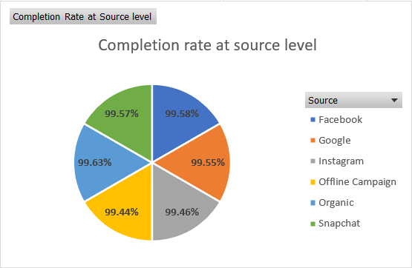

INSIGHTS

* Organic acquisition source has high completion rate of 99.63%
* Whereas, Offline campaign has low completion rate of 99.44%

11. Calculate LTV for every customer.

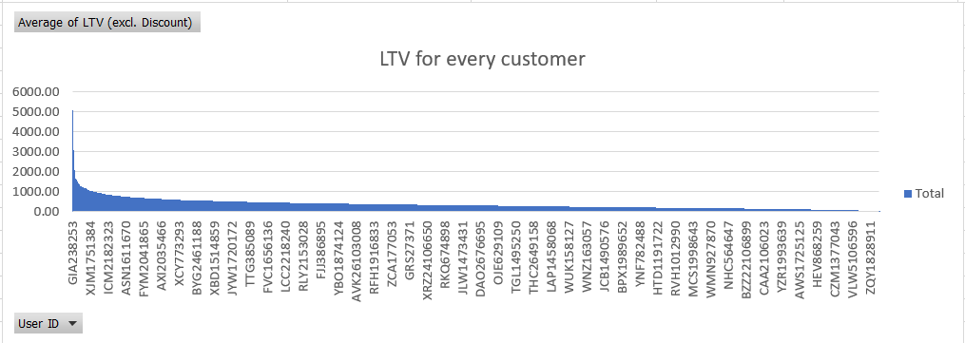

INSIGHTS

* Consumer with User ID GIA238253 has highest LTV of 5065.00
* Consumers with User ID ODG1034371 and BGR2372960 have lowest LTV of 15.00 each

12. Calculate aggregated LTV at customer acquisition source level. Refer to aggregated LTV example.

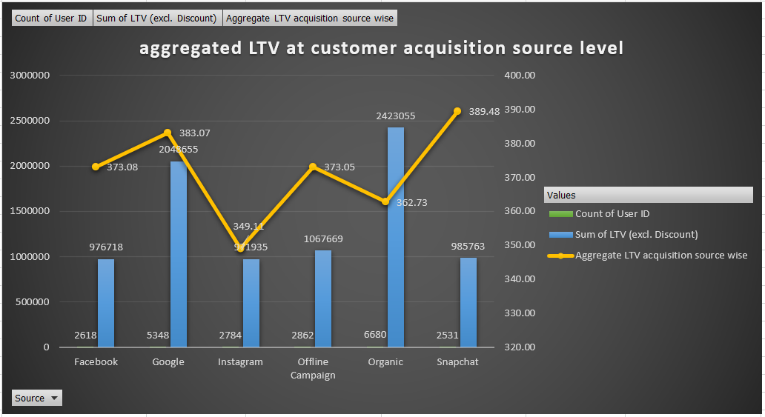

INSIGHTS

* Aggregate LTV is high for Snapchat
* Whereas, Aggregate LTV is low for Instagram
* Acquisition through Organic source is high

13. Calculate aggregated LTV at acquisition month level. Refer to aggregated LTV example.

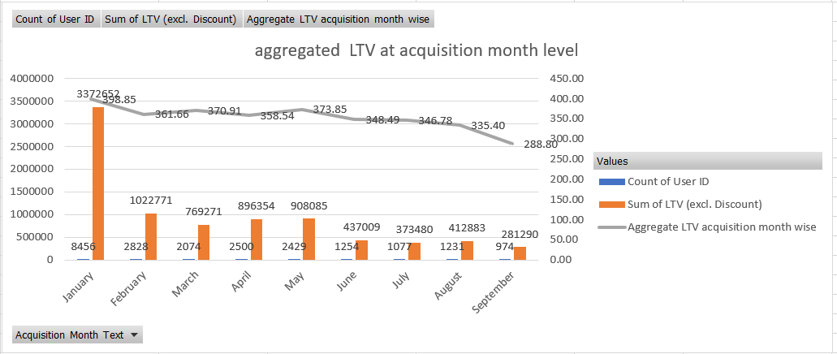

INSIGHTS

* Highest Acquisitions are during January and least acquisitions are during September
* A gradual decrease in aggregate LTV can be seen from January to September except for April and May where Acquisition has a spike
* Sum of LTV is directly proportional to Aggregate LTV

14. What is the average Revenue(Product amount after discount) per order at different customer acquisition source level?

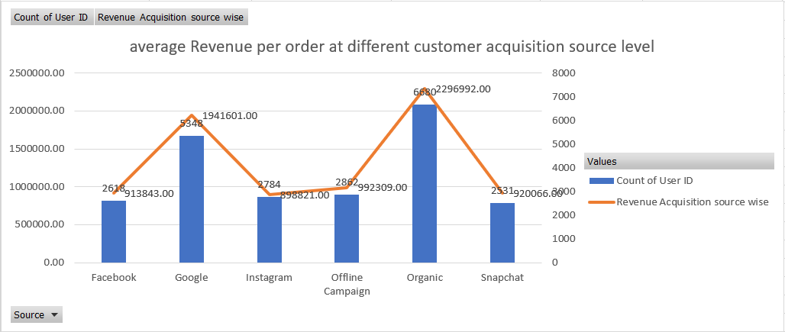

INSIGHTS

* Since Acquisition through Organic source is high, Revenue produced from Organic acquisition source is also high
* Similarly, since Acquisition through Instagram source is low, Revenue produced from Instagram acquisition source is also low

15. What is the average Revenue(Product amount after discount) per order at acquisition month level?

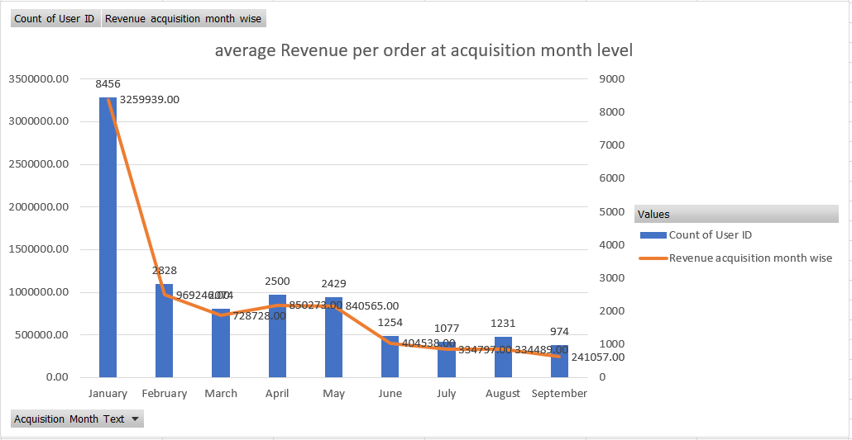

INSIGHTS

* Highest Acquisitions are during January and hence the avg. revenue produced during January is high.
* Whereas, least acquisitions are during September and hence the avg. revenue produced during September is low.
* A gradual decrease in average revenue can be seen from January to September except for April and May where Revenue has a spike
* Acquisition count is directly proportional to Revenue generated.

16. Is there any pattern in order rating across slots, number of items placed, delivery charges, discount. For example, there might be an insight from the data that orders placed during late night are generally rated high. While orders placed in early morning are not rated high. OR orders having more than 5 items are generally rated high.

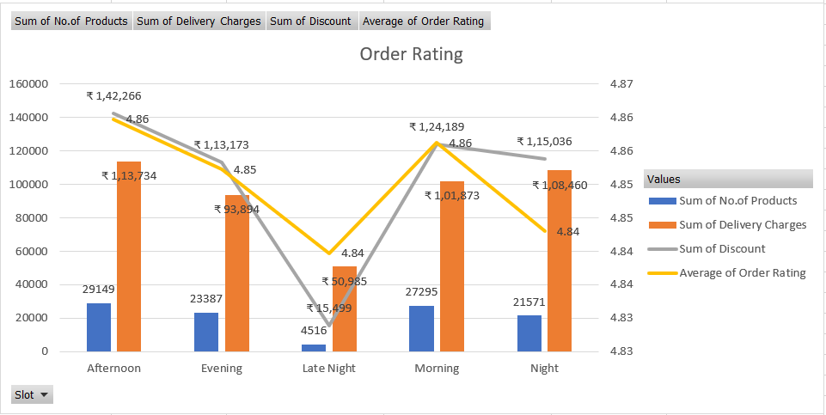

INSIGHTS

* Average rating is high during Morning and Afternoon slot which is around 4.86
* Average rating is low during Night and Late Night slot which is around 4.84
* Delivery charges during Afternoon slot is high but, it also has high customer rating
* Delivery charges during Night slot is high and it has low customer rating
* Discounts provided during Afternoon slot is high
* Whereas, Discounts provided during Late Night slot is low

FACTORS AFFECTING AT CUSTOMER LEVEL

* CUSTOMER SERVICE
  + DISCOUNT : Low discounts can affect count of orders as it does not attract the consumers quickly.
  + PROMOTIONS / OFFERS : No or Low promotions / Offers can tend to attract very less consumers
  + PAYMENT OPTIONS : Restricting to fewer payment methods provide less options for consumers to pay
* OPERATIONAL CHARGES
  + DELIVERY CHARGES : High delivery charges leads to consumers moving out to other vendors with better operational charges
  + SURGE FEES : Inducing Surge fees for extra distance or during extreme climatic conditions fails in attracting consumers
* ECONOMIC FACTORS
  + INCREASED PRICE OF PRODUCTS : Products price can be increased due to less production of raw materials, high import/export charges etc.,
  + PRODUCT QUALITY & QUANTITY : There can be low quality goods produced due to pandemic, climatic conditions or unavailability of farm products
* COMPETITION
  + BETTER PRICE : Opposition sales platform can provide better price to attract more consumers.
  + BETTER CUSTOMER SERVICE : Opposition sales platform can provide more discounts, promotions.
* UNFORSEEN FACTORS
  + DELIVERY RESTRICTIONS : Some Geos can be zoned to restrict delivery
  + NATURAL CALAMITIES : Floods, Earthquakes and more

SOME OF THE BEST PRACTICES TO IMPROVE CUSTOMER SATISFACTION

* Increasing discount% for each product without affecting overall profit of the company
* Providing special offers or User specific Promotion codes which helps in attracting more consumers
* Improving Marketing strategies via social media and other platforms
* Providing possible payment options during checkout
* Making sure to provide best consumer service and compete with the opposition parties in a healthy way
* Improving website navigations and clean UI
* Attractive hoardings and posters

DELIVERY LEVEL ANALYSIS

By performing Delivery level analysis, we can get Insights on delivery time taken to deliver an order in a specific delivery area. It also helps to identify delivery charges across various order drop geos.

Also, in the Analysis given we have average delivery time calculated at slot level, at delivery month level and delivery charge calculated across slot and delivery area.

VARIOUS LEVEL OF ANALYSIS DONE :

17. Calculate average overall delivery time at month and delivery area level.

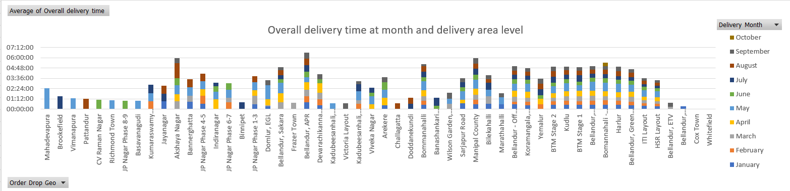

INSIGHTS

* Cox Town, Whitefield are having 0 successful orders and hence having 0 delivery time.
* Delivery to Mahadevapura is done very late
* Delivery during May month is very late
* Mahadevapura, Brookefield, Vimanapura, Pattandur, CV Raman Nagar, Richmond Town, JP Nagar Phase 8-9, Basavanagudi has orders during single month and delivery time is high
* Bomannahali – MicoLayout has orders all over the months and the average delivery time is 00:32:56

18. Calculate average overall delivery time at month and weekday/weekend level. You might need to create a column which will tag every date to either weekday or weekend.

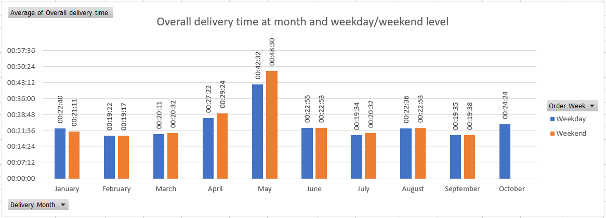

INSIGHTS

* Delivery during May month is very late
* During October, there are only orders during Weekdays and no orders during weekend
* Usually during weekend, the delivery time is high

19. Calculate average overall delivery time at slot level. Refer to the definition of slot.

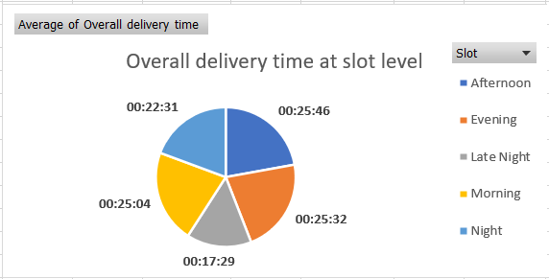

INSIGHTS

* Delivery during Late Night slot is very quick due to low traffic
* Whereas, Delivery during Afternoon slot is very late

20. Do you see any pattern in delivery charges with slot or delivery area.

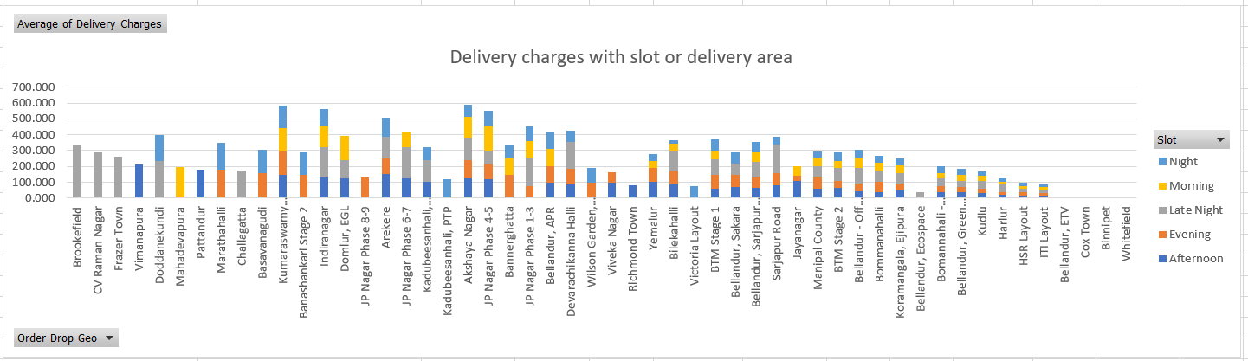

INSIGHTS

* Brookefield has only late night orders and has high delivery charges
* Orders delivered to Bellandur, Binnipet has 0 delivery charges
* Orders delivered to ITI Layout has low delivery charges
* HSR Layout has high number of orders and minimum delivery charges

21. Do you see any pattern in delivery time and delivery area. If yes then find out logical reason.

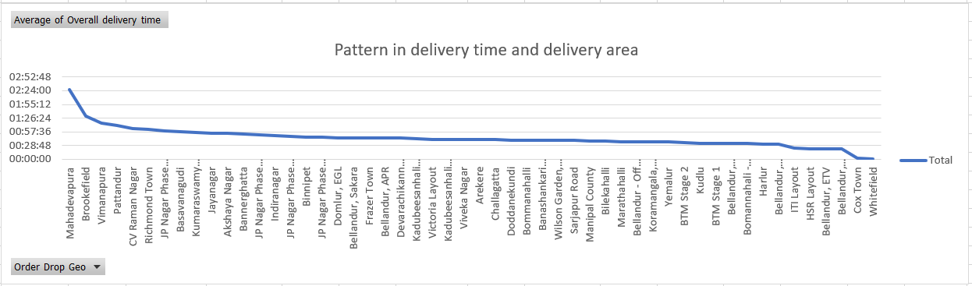

INSIGHTS

* Cox Town, Whitefield are having 0 successful orders and hence having 0 delivery time.
* Delivery to Mahadevapura is done very late
* Mahadevapura, Brookfield, Vimanapura, Pattandur, CV Raman Nagar, Richmond Town, JP Nagar Phase 8-9, Basavanagudi has orders during single month and delivery time is high
* Bomannahali – MicoLayout has orders all over the months and the average delivery time is 00:32:56

FACTORS AFFECTING DELIVERY

* LABOUR AND MANPOWER
  + EMPLOYEE ABSENTEEISM : Reduced number of staffs engaged in delivery can delay in delivering the orders.
  + WORKPLACE ACCIDENTS : Accidents during work hours while delivering a product can lead to delay in delivery which may lead to consumer cancelling the order or the package getting damaged
  + LONG DISTANCE DELIVERY : Order drop location situated far from pickup location can be tough
* OPERATIONAL CHARGE
  + LABOUR CHARGES : Insufficient salary to the delivery partners can result in dissatisfaction of the staffs.
  + INCENTIVES : If there are no performance-based Incentives given to the staffs, they will lack motivation and disagree to work on late night shifts
  + DELIVERY CHARGES : High delivery charges leads to consumers moving out to other vendors with better operational charges
  + SURGE FEES : Inducing Surge fees for extra distance or during extreme climatic conditions fails in attracting consumers
* CONSUMER RELATED FACTORS
  + UNAVAILABILITY OF CONSUMER : If the consumer is not available during the time of delivery, it may cause cancellation
  + UNRESPONSIVE CONSUMERS : If the consumers are not responding to phone calls or messages from the delivery partners, the order cannot be completed
  + INAPPROPRIATE ADDRESS : If the consumer has provided wrong address, it may affect delivery timings and eventually leads to cancellation
* UNFORSEEN FACTORS
  + DELIVERY RESTRICTIONS : Some Geos can be zoned to restrict delivery
  + NATURAL CALAMITIES : Floods, Earthquakes and more
  + ROAD TRAFFIC & ROAD BLOCKS : Heavy traffic or road blocks can lead to extended delivery hours

SOME OF THE BEST PRACTICES TO IMPROVE DELIVERY

* Making sure to follow rotational shift system to have knowledgeable staffs at each shift.
* Taking spontaneous decisions to have complete all the deliveries for the day during emergency or unplanned leave of a staff member.
* Increasing salary of the deliver partners in a yearly manner based on their experience without affecting overall profit of the company
* Providing Incentives and special coupons for delivery partners based on their performance will motivate them to work more.
* Training the delivery partners to tackle situations when the consumer is unresponsive
* Educate the delivery partners about GPS and other navigation technologies to overcome unforeseen factors and attempt delivery
* Providing special offers or User specific Promotion codes which helps in attracting more consumers
* Providing possible payment options during checkout

ANNEXURE

WORKING

From the Raw Data sheet given, various terms have been extracted and calculated as per the need in Analysis. Below table provide a list of Terms used in Data Calculation Table.

|  |  |
| --- | --- |
| **TERMS USED (in Data Calculation Table)** | **EXPLANATION** |
| Order Timestamp | Order placed time (raw format) |
| Order timestamp new | Order placed time (Excel DateTime format) |
| Order Date | Date extracted from Order timestamp |
| Order Month number | Month number extracted from Order timestamp |
| Order Month | Month name extracted from Order timestamp |
| Order Day | Day of the week extracted from Order timestamp |
| Order Week | Order day categorized as Weekday / Weekend |
| Order Time | Time extracted from Order timestamp |
| Slot | Slot of the day extracted from Order timestamp |
| User ID | Unique User ID of the customer |
| Order Pickup Geo | Place where order placed |
| Order Drop Geo | Place where order is delivered |
| Order ID | Unique Order ID for each order |
| Products | List of products placed in each order |
| Partner Store Reach Time | Time when Delivery partner reaches the pickup location (raw format) |
| Partner store reach time new | Time when Delivery partner reaches the pickup location (Excel DateTime format) |
| Partner Store Reach Date | Date extracted from Partner Store Reach Time |
| Partner Store Reach Time2 | Time extracted from Partner Store Reach Time |
| Partner Start for Delivery Time | Time when Delivery partner starts to deliver the order (raw format) |
| Partner start for delivery timestamp new | Time when Delivery partner starts to deliver the order (Excel DateTime format) |
| Partner Start for Delivery Date | Date extracted from Partner Start for Delivery Time |
| Partner Start for Delivery Time2 | Time extracted from Partner Start for Delivery Time |
| Completed/Cancelled Timestamp | Time when Delivery is finished / cancelled (raw format) |
| Completed/Cancelled timestamp new | Time when Delivery is finished / cancelled (Excel DateTime format) |
| Completed/Cancelled Timestamp2 | Date extracted from Completed/Cancelled Timestamp |
| Completed/Cancelled Timestamp3 | Time extracted from Completed/Cancelled Timestamp |
| Delivery Month | Month extracted from Completed/Cancelled Timestamp |
| Completion Flag | Status of delivery (Yes / No) |
| Order Rating | Rating given per Order |
| Product Amount | Total Amount of products per Order |
| Delivery Charges | Delivery charge per Order |
| Discount | Discount given per order |
| Cumulative Amount (Incl. Discount) | Amount payable by customer for their order (Revenue) |
| LTV (excl. Discount) | Customer Lifetime Value |
| Source | Acquisition Source of each customer |
| Order to Arrival | Order time to Partner Store reach. |
| Arrival to pickup | Partner Store Reach Time to Partner Start for Delivery Time. |
| Pickup to Delivery | Partner Start for Delivery Time to Completed/Cancelled Timestamp. |
| Overall delivery time | Completed/Cancelled Timestamp - Order Time |
| Completed Orders | ‘1’ – Completed  ‘0’ – Cancelled (extracted from Completion Flag) |
| Order Count | No.of orders per Order ID |
| No.of Products | No.of Products per Order ID |
| Count of Orders with same Product count | No.of orders with similar product count |
| Count of Orders with same Product count & successful delivery | No.of orders with similar product count & successful delivery |
| no.of product wise completion rate | Completion rate calculated at no.of products level |
| User count with same Source | No.of users from same acquisition source |
| LTV Source wise | LTV calculated at acquisition source level |
| revenue source wise | Revenue calculated at acquisition source level |
| Acquisition date | First purchase date by the customer |
| No.of orders at acquisition date | No.of orders with same acquisition date |
| Acquisition Month | Acquisition month number extracted from Acquisition date |
| Acquisition Month Text | Acquisition month text extracted from Acquisition date |
| User count at Acquisition month | No.of users with same acquisition month |
| LTV acquisition month wise | LTV calculated at acquisition month level |
| Revenue acquisition month level | Revenue calculated at acquisition month level |